
Catherine’s February Update

Dear friends, February 17th, 2009
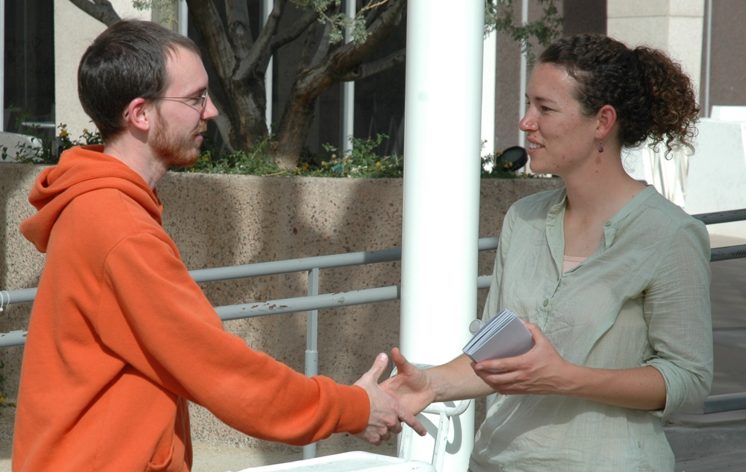
“Nobody knows when life begins!” Six high school students from a nearby leadership school (see photo above) showed up at the Justice For All Exhibit at the University of Arizona in Tucson, each with their own idea about when we become human. Rather than give a 10 minute lecture, I asked them to share with me their reasons for they believe. They did, and then we talked about the fact that humans are biologically alive at fertilization. Then we explored when we become valuable persons. They agreed that humans never have a right to decide for other living humans that they’re not valuable persons. They all left with brochures, agreeing to share what they’d learned with others.
At each JFA Exhibit outreach, our staff and volunteers challenge many pro-life folks, like this Arizona State University student (photo, right), to be active in their campus pro-life clubs. At ASU, I got to introduce two girls to Kim, a counselor who spent two full days on campus with us. The girls said they’d share the JFA Exhibit brochure with their abortion-minded friend and keep me posted by email.
I've arrived in Wichita, Kansas - my new home! JFA's national office is here and I’m now on full-time staff. I only need to raise $350/month more toward living expenses. Please let me know if you’d like to help me reach that goal. Thank you to everyone who has offered financial support, prayers and encouragement! I'm excited to be able to focus my energy full-time on JFA’s mission of “training thousands to make abortion unthinkable for millions, one person at a time.”

Please pray for:
• This month JFA travels to UT-San Antonio, Texas A&M, and the University of Texas-Austin!
• Praise God for providing supportive students and community members in all three cities.
• Praise God for providing strategic connections in Colorado and California for those spring trips.

Christ’s peace, Catherine

